# **BACHELOR IN INFORMATION TECHNOLOGY**



# **ASSIGNMENT**

**Submitted by:** **Submitted to:**

Name: Bishal Bhattarai Lincoln University

Year/ Semester: First, Fall 2019

LCID: LC00017000753

# **Date: 2020.06.27**

1. Find the Domain and Range of 

  Solution: Here,

2-x-x2=0

Or, (2+x) (1-x) = 0

Either, x =1 or, -2

The interval be (-∞,-2)U(-2,1)U(1,∞)

Now, the sign conversion,

|  |  |  |  |
| --- | --- | --- | --- |
|  | 2+x | 1-x | (2+x)(1-x) |
| (-∞,-2) | - | + | - |
| (-2,1) | + | + | + |
| (1,∞) | + | - | - |

Here, only the positive sign is taken. So, the Domain is found to be (-2,1).

For range,

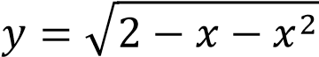

= 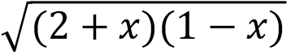

For, minimum value we take x=0, then the output will be maximum value. So the Range is (0,).

1. Find the solution of: 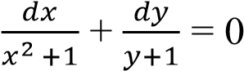
   * Solution:

Here,

Integrating both side;

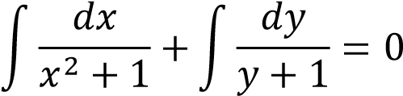

Or, tan-1x +log(y+1) =0

Differentiate: 

* + Solution: Given, y= 4sect +tant

Differentiate with respect to t we get,

Or, 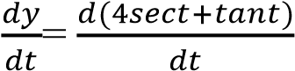

⸫ 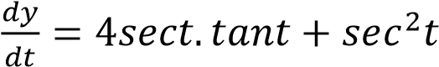

1. If f”(x)=20x3-12x2+6x, then find f(x).
   * Solution: Given, f”(x) = 20x3-12x2+6x

Integrating both sides we get,

Or, 

Or, f’(x) =-12x2+6x



Or, f’(x) = 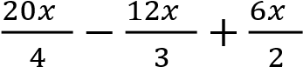

Or, f’(x) = 5x4-4x3+3x2

Integrating both sides we get,

Or, 

Or, f(x) = 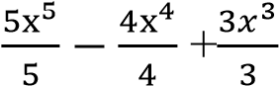

Or, f(x) = x5-x4+x3

Hence, f(x) is found to be x5-x4+x3.

1. Find the area enclosed between x axis, the curve y= x3-2x+5 and the ordinates x=1 and x=2.

➢

Solution:

Here,

Given,

y= x

3

-

2

x

+5

x=1, x=2

Y

4

1

2

0

1

2

X

From the formula;

Area= 

Now a=1 and b=2 then the function becomes

A= 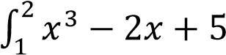

A= 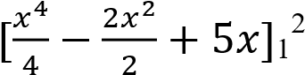

A= [4-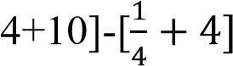

A= 10-

⸫ A= 5.75 sq.unit

Hence, the area enclosed between x-axis is found to be 5.75 sq unit.

1. Find 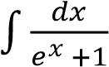(Antiderivatives)
   * Solution: Given,

Or, 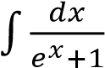

Or, 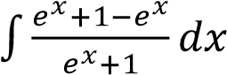

Or, 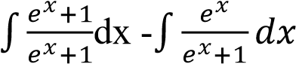

Or, x+1)

Or, x- ln(ex+1) +C

⸫ Antiderivatives of the function 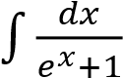 is found to be xln(ex+1)+C.

State and Verify mean value theorem for f(x)= x3-x in [0,2] ➢ Solution:

Here,

Given function is f(x) = x3-x which is continuous on close interval [a,b]

Then, there exist some number in c in [a,b] such that f’(c)

f’(c) = 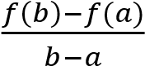

[a,b]=[0,2]

Then, a=0 and b= 2.

Now, f(a)=x3-x Or, f(0)=0 f(b)= x3-x f(2)= 6

Or, f’(c) = 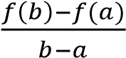

Or, f’(c) =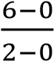

⸫ f’(c) =3

Again, f’(c)= 3x2

From above we found f’(c)= 3

Or, 3= 3x2

Or, x= 1

Therefore, 1 lies between the interval 0 and 2. Hence, it proves mean value theorem.

*** ***